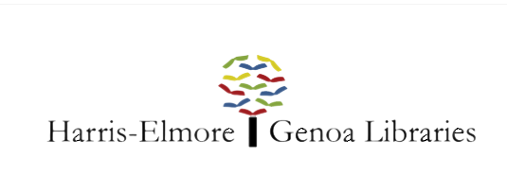

Memorial & Honor Contributions Donation Form

A gift to the Harris-Elmore Public Library or the Genoa Branch Library for a loved one is a meaningful way to honor or memorialize that person.

When you make a tribute or memorial gift, The Harris-Elmore Public Library will send a letter to the recipient or the recipient’s family to let them know about your gift. We will also send an acknowledgment to you as the donor.

ENCLOSED IS MY GIFT IN THE AMOUNT OF:

$10
$25_ _ $50
$100_ _ $1,000
Other $_ _

DONOR OF CONTRIBUTION AND HONOREE/DECEDENT INFORMATION

In Memory of ____ _ or In Honor of

Donor/Company Name
Address
City_ State_ Postal Code _ _
E-mail __ _ _ Phone __

PLEASE SEND NOTIFICATION OF THIS CONTRIBUTION TO:

Family or Individual_

Address

City_ State_ Postal Code _ _

Is there a certain library item (book, furniture, etc) that you would like the donation to be used toward? *Nameplates are included in any item purchased

Would you like us to include the contribution amount in the notification letter? Yes _or No _

Please mail this form along to Harris-Elmore Public Library P.O. Box 45 Elmore, OH 43416 or the Genoa Branch Library 602 West St. Genoa, OH 43430 along with your check made out to the Harris-Elmore Public Library.

You can also make Memorial & Honor Contributions by phone by calling 419-862-2482, or online by going to www.harriselmorelibrary.org/donate.

