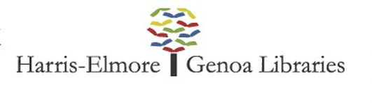
Minutes of the Harris Elmore Public Library
Board of Trustees Emergency Meeting
Friday, March 13, 2020

Present: David Selhorst (President), Judy Zimmerman (Vice-President), Toby Farrell (Secretary), Leslie Wyse, Linda Bringman (per phone)
Library Staff Present: Jennifer Fording (Director), Ariel Gresh (Branch Manager)
Absent: Brianne Markley (Fiscal Officer), Kent Weis, Ron Busdeker

- CALL TO ORDER: President Mr. Selhorst called the meeting to order at 6:05 p.m. at the Elmore facility.

2. NEW BUSINESS:
- Corona Virus Action – Due to the Corona Virus CDC health recommendations all Library programs and outreach services have now been suspended through the month of March. Discussion was held regarding the possible future closing of both Elmore and Genoa Branch libraries. Mrs. Fording presented several options for the Board to evaluate in order to make a decision regarding the best practice closure.
Resolution 2020-19. Be it resolved to close the Elmore and Genoa Branch Libraries to public admittance with Curbside Service (by reservation) available during reduced hours provided by the Library staff working reduced hours but receiving regular pay, effective March 18 – April 6, 2020.
Motion made by Leslie Wyse. Motion seconded by David Selhorst.
Motion carried by unanimous voice vote.

3. ADJOURNMENT: 7:44 p.m.

4. NEXT MEETING: March 19, 2020 at Elmore Library

Respectfully submitted:
Ms. Toby Farrell, Secretary

____________________________________________ __________________________________________
Toby Farrell-Secretary David Selhorst-President

